**Homework Wan Huzaifah bin Wan Azhar**

The program relocation.py allows you to see how address translations are performed in a system with base and bounds registers. See README for details.

**Answer:**

1. Check if violate bound. If not, translate the address.

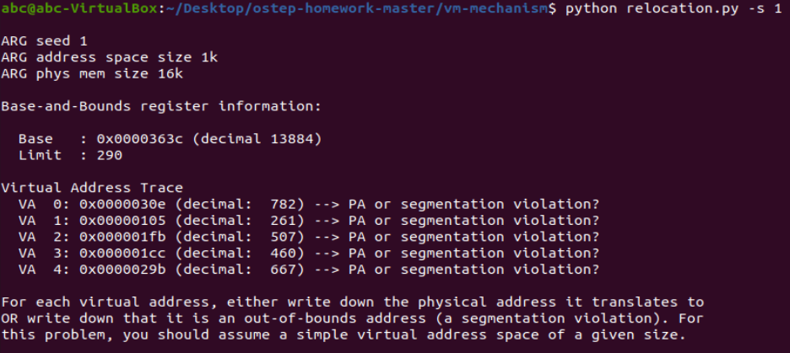

VA0: Segmentation violation  
VA1: Valid address at 14145  
VA2: Segmentation violation  
VA3: Segmentation violation  
VA4: Segmentation violation

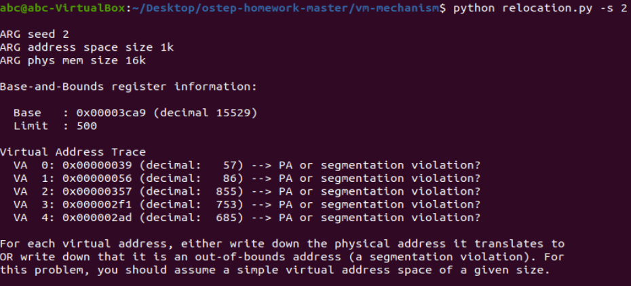

VA0: Valid address at 15586  
VA1: Valid address at 15615  
VA2: Segmentation violation  
VA3: Segmentation violation  
VA4: Segmentation violation

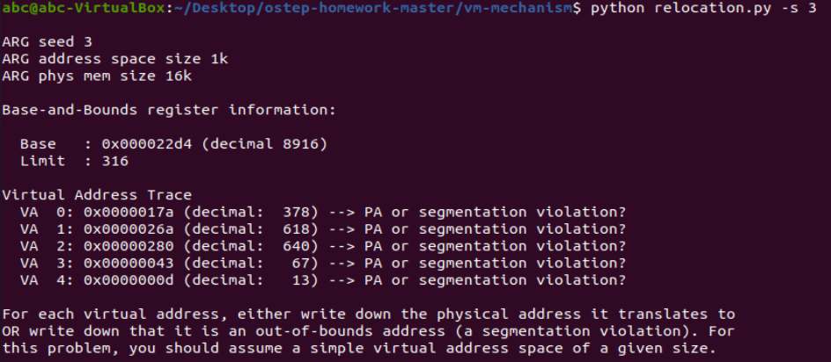

VA0: Segmentation violation  
VA1: Segmentation violation  
VA2: Segmentation violation  
VA3: Valid address at 8983  
VA4: Valid address at 8929

1. What bound to set so that all address is valid?

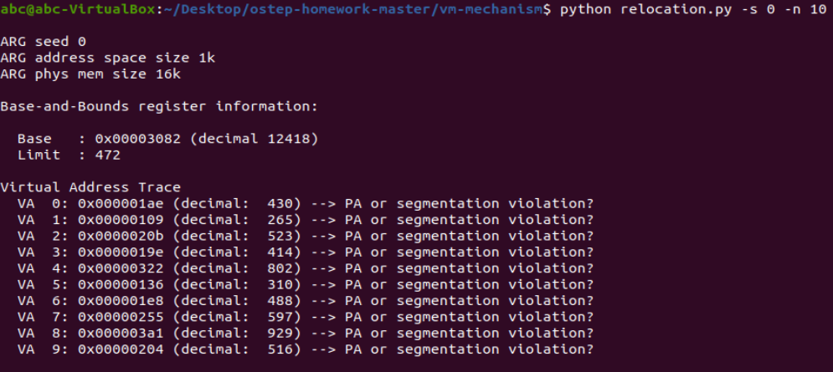

The bounds should be set to higher than 929 so that the highest address of 929 can be valid address. 929 is not a valid bound because bound start from 0, so valid virtual address is between 0-928.

1. What maximum base value can fit the address space into the physical memory?

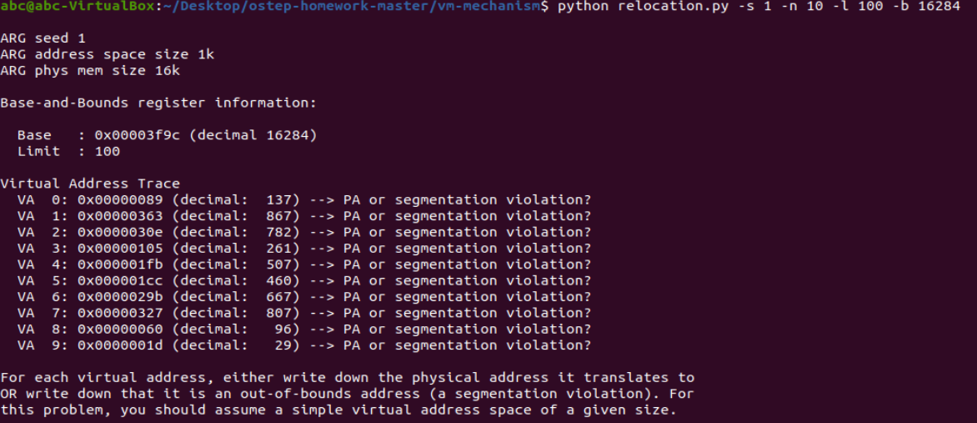

As limit is 100, the maximum base value should be (total physical memory – limit). 16k to bytes is 16384. Therefore, maximum bound value is 16284.

4. Skipped because the question is unclear

5. Plotting valid VA of 4 seed with varied bounds value

From the graph, the ratio of valid address increase as bound value increase, which is as expected.